Photometric determination of ammonium (NH₄⁺) concentrations in water samples

Preparation of the water samples:
- centrifugation, if needed filtration through 0.45 µm membrane filter
- dilute the water samples 1:5 and 1:10
- use both undiluted and diluted samples for the analysis

Reagents (provided):
- 2 % sodium phenolate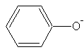 solution (2 g in 100 ml MilliQ-water)
- 0.005 % sodium nitroprusside (Na₂[Fe(CN)₅NO]·2H₂O) solution (5 mg in 100 ml MilliQ-water)
- sodium hypochlorite-sodium hydroxide solution (45 ml 0.125 M NaOH + 5 ml sodium hypochlorite-solution)

Standard series for calibration:

- Prepare a 100 mM NH₄Cl stock solution with MilliQ-water in a 50 ml analytical flask. (NH₄Cl: M=53.49 g/mol). 267.5 mg/ 50 ml are needed, weigh in plastic weighing boats and flush quantitatively into flask using a funnel. Use MilliQ-water. Fill up to 50 ml calibration line and mix.
- Prepare 1 mM working solution from 100 mM stock solution (0.5 ml of the stock to a final volume of 50 ml with MilliQ-water).
- Prepare the following standards from the working solution:

5 µM | (125 µl in 25 ml-analytical flask) | 0.09 mg/l „
10 µM | (250 µl in 25 ml analytical flask) | 0.18 mg/l „
50 µM | (1.25 ml in 25 ml analytical flask) | 0.90 mg/l „
100 µM  200 µM | (2.5 ml in 25 ml analytical flask)  (5 ml in 25 ml analytical flask) | 1.80 mg/l „  3.60 mg/ l „

For the photometric measurement, you will need a blank (MilliQ-water + reagents). Do not forget when preparing your samples!

Preparation (in short glass tubes):

      - Add 1 ml of the water sample, blank or standard, respectively
      - + 0.5 ml sodium phenolate solution
+ 0.25 ml sodium nitroprusside solution
+ 0.25 ml sodium hypochlorite-sodium hydroxide solution
      - Mix by vortexing for 5 sec.
      - Incubate for 30 min at 30°C in the dark; put tubes with a rack into the water bath with the lid closed.
      - Measure absorption at 630 nm in 1.5 ml- cuvettes (half-micro).

Example: calibration on 14.09.2005
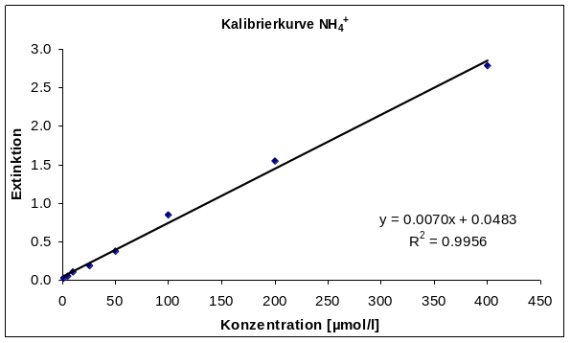
µM | value
1 | 0.0238
5 | 0.0512
10 | 0.1022
25 | 0.1924
50 | 0.3758
100 | 0.8542
200 | 1.5484
400 | 2.7815

